DINNER FOR TWO
Класс 8 Тема «Meals », Урок 8
https://www.youtube.com/watch?v=JU6ktdFjO-w
Before you watch 1. Match the food and the pictures

a. milk b. bread c. potatoes d. mushrooms e. pasta f. meat
g. rice h. tomatoes i. fish. J. fruit k. onion
1.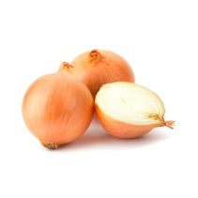 2. 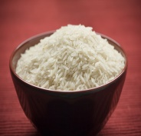 3. 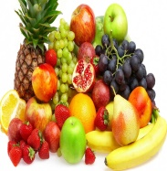 10. 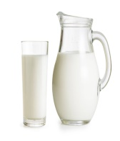

4.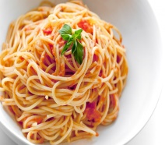 5.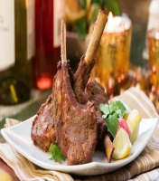 6.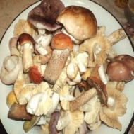 11.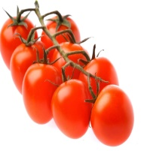

7.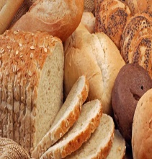 8. 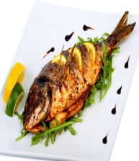 9. 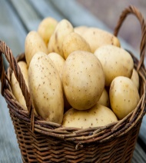
2. Are the words countable or uncountable? Put them in the correct column.
Countable | Uncountable
3. While you watch. Tick the correct answer.
1. What is David cooking? 2. Who is he coking for? 3. What does he want Matt and Helen do?
- Chinese chicken with chilli his housemates - help him
- Thai chicken with chilli himself - stay at home
- Mexican chicken with chilli his girlfriend - go out
4. What’s wrong with the dish? 5. Where is Julia? 6. Who adds more chilli powder?
- It needs more salt - at the station - just Matt
- It needs more chilli powder - at the door - just Helen
- It needs more chicken - at home - all of them
4. Tick the ingredients which Jane asks about.
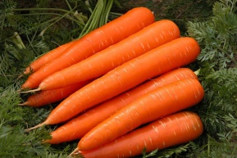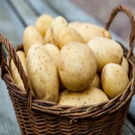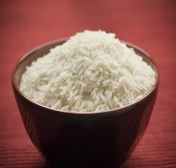

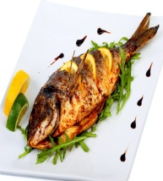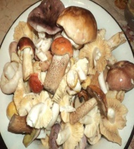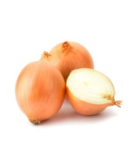
After you watch
You are at the supermarket. You want to make a strawberry cheesecake for the evening. Phone home to check if you have the following ingredients:
Cream cheese biscuits strawberries milk flour lemons

